Memorandum of Agreement Use of the ISST LOGO
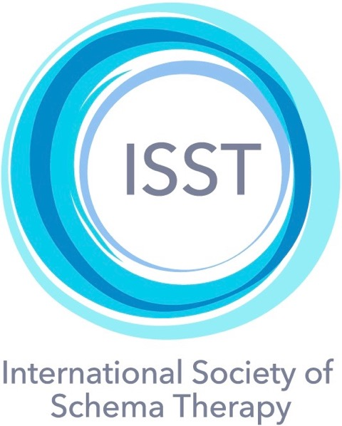

I, , request authorization from the Executive Board of
(Print Name)
The International Society of Schema Therapy (ISST) to utilize the official ISST logo based on the following limitations: to be displayed on promotional materials (including web-page advertising, marketing brochures, registration applications, attendee certificates of program completion, and attendee handouts) that are directly related to my ISST-approved certification training program.

I understand that this authorization ONLY applies to trainers who have already received written approval for their ISST certification training programs, from the Training Coordinator of the ISST Board.

I also agree to send a copy of all materials that will host the logo, including a link for my webpage where the logo will appear, to the ISST board president and board secretary, Eckhard Roediger: kontakt@eroediger.de and Chris Hayes
chrishayesperth@gmail.com

I understand that any further use of the ISST logo is prohibited without the written consent of the ISST Board president.

As an active ISST member and representative of the “society”, I understand that the ISST Board can revoke this authorization should I fail to abide by this agreement, and/or violate customarily expected professional and ethical standards of clinical practice and clinical education.

Signed Date

Approved – ECKHARD ROEDIGER, ISST President Date

